LIFE & FAITH

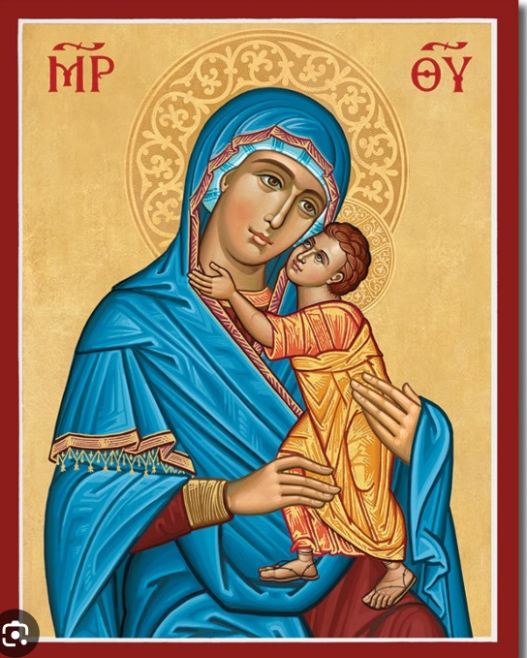

Adult Formation

Church of the Redeemer

September 2023-December 2023

Sessions on Life and Faith Sunday 9:15 a.m.
We do not “check our brains” at the church door. We gather to study and discuss a variety of topics related to our faith and life. You may come to any or all of the forums without registration.

September
10 Registration & Commission
17 Evangelism for Everyday Life Rev. M. Siegmund
24 Gun Violence Prevention Tara Bennett

October
1 Todays Lessons Rev. M Siegmund
8 Book of Revelation Dr. David May
15 Book of Revelation Dr. David May
22 Book of Revelation Dr. David May
29 Book of Revelation Dr. David May

November
5 Intro to Mark Judy Carpenter
12 Intro to Mark Judy Carpenter
19 Episcopal Identity Dr. Bill Stancil
26 Episcopal Identity Dr. Bill Stancil

December
3 Episcopal Identity Dr. Bill Stancil
10 Episcopal Identity Dr. Bill Stancil
17 Today’s Lessons David Grosse
24 No Forum
31 No Forum

